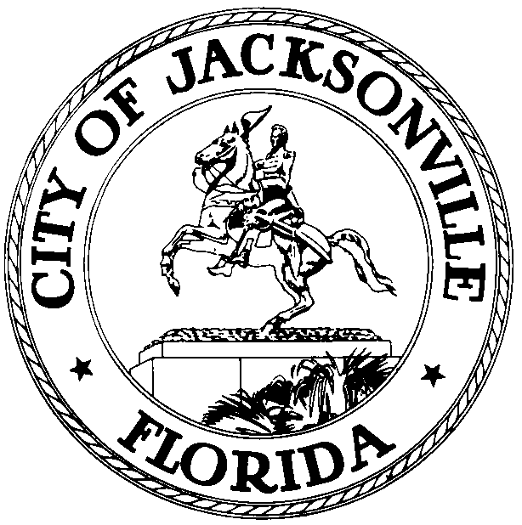

OFFICE OF THE CITY COUNCIL

DR. CHERYL L BROWN 117 WEST DUVAL STREET, SUITE 425
DIRECTOR/COUNCIL SECRETARY 4th FLOOR, CITY HALL
OFFICE: 904-630-1452 JACKSONVILLE, FLORIDA 32202
FAX: 904-630-2906
EMAIL: CLBROWN@COJ.NET

July 14, 2016
(5:00 P.M.)

AMENDED NOTICE

MEMORANDUM

TO: Standing Committees Chairpersons
Council Members
Council Staff

FROM: The Honorable Lori N. Boyer, President-Designate
Jacksonville City Council

RE: July 1, 2016 through June 30, 2017 Standing Committee
Meeting Assignments, Dates, Times, Meeting Locations

Notice is hereby given that the Honorable Lori N. Boyer, President –Designate, Jacksonville City Council sets the following meeting dates and times for the Standing Committees and Standing Committee Agenda Meetings. The Chairmen of the Jacksonville City Council will meet with the Standing Committee Members on the first and third week of each month in the Council Chamber, 1st Floor, City Hall at St. James, 117 West Duval Street, Jacksonville, Florida. (See individual Committee information below for details on meeting dates, times, and locations.) These meetings take place at the times listed below unless there is a holiday upon which the meetings will take place 24 hours after the holiday.

STANDING COMMITTEE SCHEDULE:

Neighborhoods, Community Investments and Services Committee
(Parks, Libraries, Housing and Neighborhoods)

The Committee shall consider matters relating to parks, recreation; public housing; affordable housing; farms; forestry; fish and game; zoo; Sister Cities program; Jacksonville Public Library; Parks, Recreation and Entertainment Department; Agriculture Department; Jacksonville Housing Commission; Jacksonville Housing Authority; Community Services Department; ad valorem property tax exemptions; historic preservation; community revitalization; Waterways Commission; vessels for hire; Urban Services Districts; the Neighborhoods Department; education and schools; Duval County School Board; literacy issues; higher education institutions and issues; veterans' issues; Jacksonville Children's Commission; child services; service quality improvement and public satisfaction with government services
Committee Members:
Scott Wilson - Chair
Reggie Brown - Vice Chair
Doyle Carter
Garrett Dennis
Bill Gulliford
Joyce Morgan
Matt Schellenberg

NCIS Committee Agenda Meeting Location/Time:
First and Third Monday at 8:30 a.m.
Lynwood Roberts Room, First Floor City Hall
117 W. Duval Street

NCIS Committee Meeting Location/Time:
First and Third Monday at 9:00 a.m. (will adjourn no later than 11:15 a.m.;
(Special Committee on Community Services Matters to follow immediately upon adjournment and Special Committee to adjourn no later than noon)
Council Chamber
First Floor, City Hall
117 W. Duval Street

Transportation, Energy and Utilities Committee

The Committee shall consider matters relating to roads and streets; concurrency; mobility fees and mobility plan; Context Sensitive Streets; transportation; transportation planning; multimodal transportation issues; intelligent transportation systems (ITS); North Florida TPO; railroads; deregulation of utilities; ambulances; towing; vehicles for hire; transit; public utilities or utility-related services; JEA (water and sewer operations, chilled water operations, water supply planning, water re-use; sewer line extensions, and other non-budgetary issues, power generation and distribution); Public Works Department; refuse collection; environmental services; public parking; Stormwater Utility and drainage matters; Septic Tank regulations and phase-outs; Environmental Resource Management Department; landfills; Jacksonville Transportation Authority; Jacksonville Aviation Authority; Jacksonville Port Authority
Committee Members:
Al Ferraro - Chair
Doyle Carter - Vice Chair
Greg Anderson
Anna Lopez Brosche
Reggie Brown
John Crescimbeni
Reggie Gaffney

TEU Committee Agenda Meeting Location/Time:
First and Third Monday at 1:30 p.m.
Lynwood Roberts Room, First Floor City Hall
117 W. Duval Street

TEU Committee Meeting Location/Time:
First and Third Monday at 2:00 p.m. and adjourn no later than 4:30 p.m.
(Special Committee on TEU Matters to follow.)
Council Chamber
First Floor, City Hall
117 W. Duval Street

Public Health and Safety Committee

The Committee shall consider matters relating to the Department of Health; public health, international travel, wellness; mental health; addiction; human services; homelessness; public assistance; Public Service Grants, public safety; safety hazards and dangerous infrastructure; motor vehicle inspections; collections; crime and crime prevention; victim services; Jacksonville Journey; Sheriff's Office; police-community relations; Fire and Rescue Department; emergency preparedness and civil defenses; military bases; personnel and affairs; base realignment and closure (BRAC) issues; and all related subjects.
Committee Members:
Sam Newby - Chair
Bill Gulliford – Vice Chair
Aaron Bowman
Anna Lopez Brosche
Katrina Brown
Tommy Hazouri
Joyce Morgan

PHS Committee Agenda Meeting Location/Time:
First and Third Tuesday at 8:30 a.m.
Lynwood Roberts Room, First Floor City Hall
117 W. Duval Street

PHS Committee Meeting Location/Time:
First and Third Tuesday at 9:00 a.m. (will adjourn no later than 11:15 a.m.; Special Committee on PHS Matters to follow and adjourn no later than noon)
Council Chamber
First Floor, City Hall
117 W. Duval Street

Rules Committee

The Committee shall consider matters relating to confirmation of nominations by the Council, Mayor and Sheriff; rules; laws; executive communications; resolutions; memorials; calendar; agenda; charter revision; governmental reorganization; City Council and School Board redistricting; elections; courts; consumer affairs; "J-Bills" and legislation before the Florida Legislature; service quality improvement and public satisfaction with government services; advanced communication and technology use and "e-government"; Boards and Commission structures and all related subjects .and all unclassified subjects
Committee Members:
Garrett Dennis - Chair
John Crescimbeni - Vice Chair
Greg Anderson
Danny Becton
Tommy Hazouri
Jim Love
Scott Wilson

Rules Committee Agenda Meeting Location/Time:
First and Third Tuesday at 12:30 p.m.
Lynwood Roberts Room, First Floor City Hall
117 W. Duval Street

Rules Committee Meeting Location/Time:
First and Third Tuesday at 1:00 p.m. (will adjourn no later than 3:15 p.m.; Special Committee on Rules Matters to follow and adjourn no later than 4 p.m.)
Council Chamber
First Floor, City Hall
117 W. Duval Street

Land Use and Zoning Committee

The Committee shall consider land use and zoning matters, including zoning; preservation; conservation; building codes; urban renewal; real estate; land use; land, water and wetlands preservation; water supply issues; comprehensive planning; strategic planning; current planning; growth management and implementation of state statutes regarding same; Planning and Development Department; appeals from Planning Commission decisions; growth management; transportation concurrency and mobility; school concurrency; monitoring and implementation of the new State growth management laws; actively participate in amending and updating Jacksonville's Comprehensive Plan, including reviewing all text amendments and Future Land Use Map Amendments to the comprehensive plan; and all related subjects.
Committee Members:
Danny Becton - Chair
Jim Love - Vice Chair
Doyle Carter
Al Ferraro
Reggie Gaffney
Joyce Morgan
Matt Schellenberg

LUZ Committee Agenda Meeting Location/Time:
First and Third Tuesday at 4:15 p.m.
Lynwood Roberts Room, First Floor City Hall
117 W. Duval Street

LUZ Committee Meeting Location/Time:
First and Third Tuesday at 5:30 p.m. (Special Committee on LUZ matters to precede at 4:45 p.m. unless pre-empted by appeal hearing)
Council Chamber
First Floor, City Hall
117 W. Duval Street

Special Committee on Land Use and Zoning Matters
First and Third Tuesday at 4:45 p.m.
Finance Committee

The Committee shall consider financial matters, including appropriations; budgets; budgetary transfers; taxes; fees; franchises; bonds; fiscal and investment policies; economic development investment incentives and related contracts, agreements and appropriations; licensing; personnel; pensions; leases; Administration and Finance Department; Procurement Department; Office of Economic Development; JEA financial issues; auditing; performance measurement and benchmarking; audits of the City and Independent Agencies; selection and retention of the auditor to perform the annual independent audit required by Section 5.11, Jacksonville Charter; TRUE Commission reports; international trade and all related subjects
Committee Members:
Anna Lopez Brosche - Chair
Matt Schellenberg – Vice Chair
Greg Anderson
Aaron Bowman
Katrina Brown
Bill Gulliford
Sam Newby

Finance Committee Agenda Meeting Location/Time:
First and Third Wednesday at 8:30 a.m.
Lynwood Roberts Room, First Floor City Hall
117 W. Duval Street

Finance Committee Meeting Location/Time:
First and Third Wednesday at 9:00 a.m. (will adjourn no later than noon, Special Committee on Finance matters to follow immediately)
Council Chamber
First Floor, City Hall
117 W. Duval Street

All interested parties are invited to attend.

Please contact Legislative Services at (904) 630-1404 for additional information.

LNB/clb/clo

cc: Council Members/Staff
Cheryl L Brown, Director/Council Secretary
Carol Owens, Interim Chief – Legislative Services
Jeff Clements, Chief of Research
Kristi Sikes, Chief of Administrative Services
CITYC@COJ.NET
Electronic Notice Kiosk – 1st Floor City Hall
Public Notice System – City Council Web Page
Media Box
File Copy

